Ein Bild, das Tisch, Zeichnung enthält.

**OpenTwin** – Service communication documentation

Version 1.0

# Table of Content

Table of Content 2

1. Introduction 3

2. Normal process 4

2.1 Log-in 4

2.2 Create new session 6

2.3 Close session by User 7

3. Document Version History 8

# Introduction

This documentation describes the communication between open twin services.

# Normal process

## Login

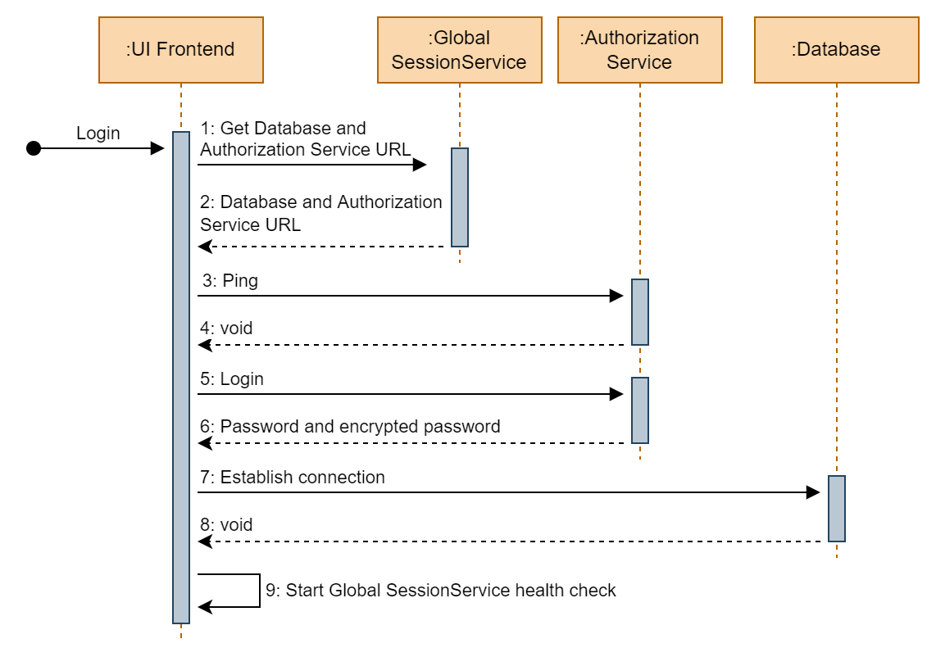

### Message syntax

#### Message 1

|  |
| --- |
| {  "action": "GetDatabaseAuthURL",  "Msg": "UI.LogIn"  } |

The first message will request the database and authorization service URL from the Global session service. The global session service will reply with the database and authorization service URL.

#### Message 2

|  |
| --- |
| {  "Service.DbUrl": "<Database URL>",  "Service.AuthUrl": "<Authorization service URL>"  } |

The response from the global directory service contains the database and authorization service URL.

#### Message 3

|  |
| --- |
| {  "action": "Ping"  } |

The ping message to the authorization service will be sent via one-way tls. If the message was successfully delivered, then the ping was successful.

#### Message 5

|  |
| --- |
| {  "action": "Login",  "Username": "<Username>",  "Password": "<Password>",  "EncryptedPassword": true/false // True if the provided password is encrypted  } |

The login message to the authorization service contains the username, password and a flag that indicates if the provided password is encrypted. The authorization service will check if the login credentials are valid.

#### Message 6

|  |
| --- |
| {  "successful": true/false, // True if the provided login credentials are valid  "Password": "<Password>", // Only added if successful is true  "EncryptedPassword": "<Encrypted password>" // Only added if successful is true  } |

The response to the login message contains the member “successful” that indicates if the login was successful or not. If the login was successful, the response also contains the password and the encrypted password.

#### Message 7

If not connected to the database already, a new connection will be established. If a connection was successfully established, a test request will be executed. If both the connection and the test request were successful than a valid database connection is assumed.

## Create new session

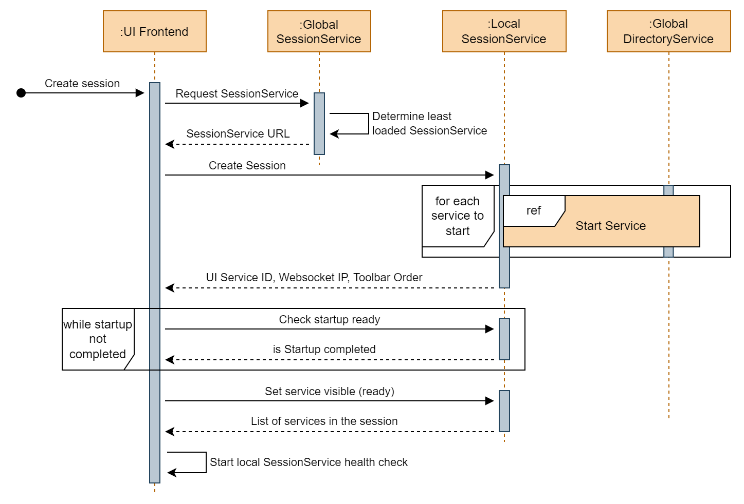

## Start service

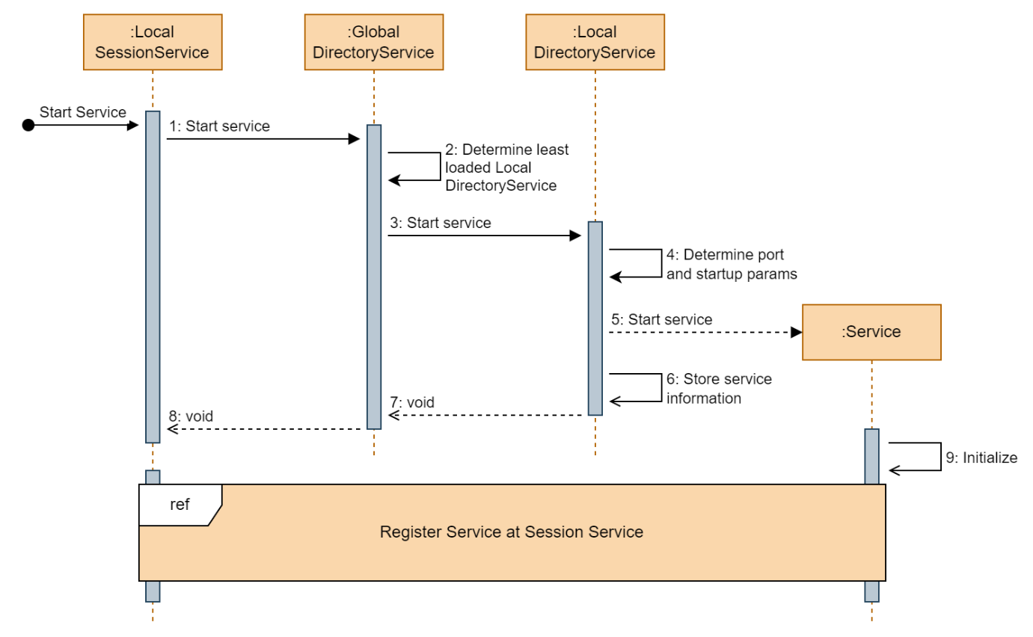

## Register service at local session service

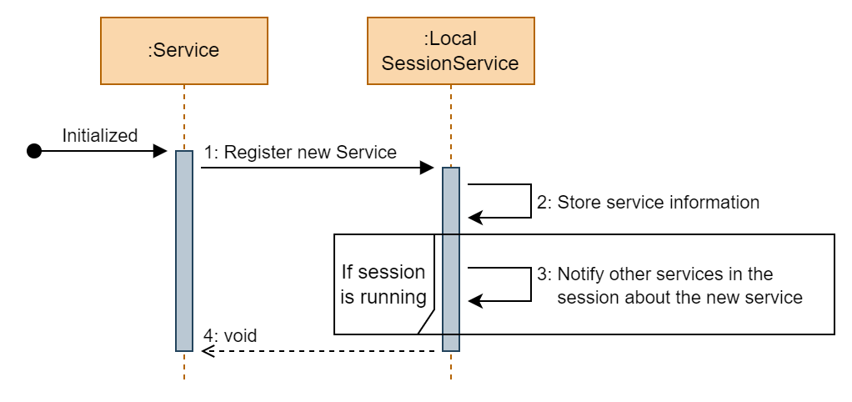

## Close session by User

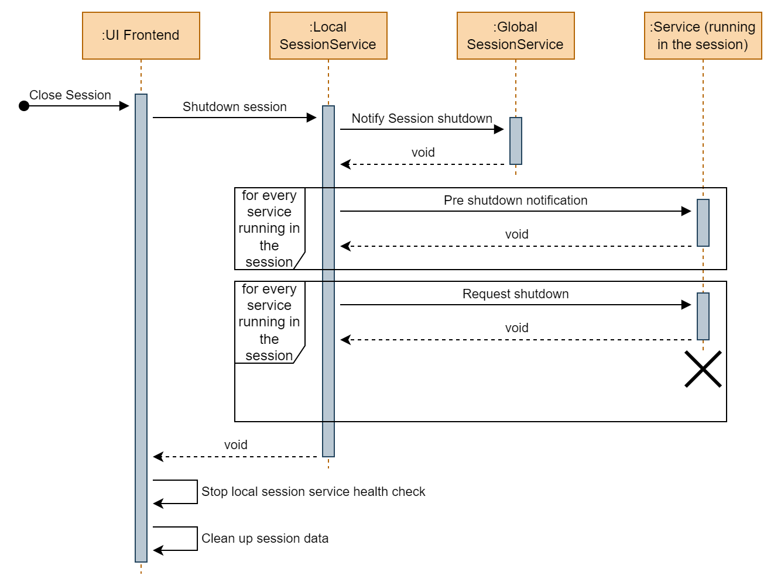

# Document Version History

|  |  |  |  |
| --- | --- | --- | --- |
| Version Nb. | Changes | Editor | Date |
| 1.0 | Creation of document | Alexander Küster | --.09.2022 |